WEEK4: FINAL REPORT

INTRODUCTION:
This report presents the analysis of ATM transaction performance using Microsoft Power BI. The dashboard helps visualise key business metrics such as total transactions, success rate, failure rate, and average processing time. The objective is to monitor system performance and identify operational efficiency.
OBJECTIVE:
The main objectives of this analysis are:
- To analyse ATM transaction performance
- To measure transaction success and failure rate
- To calculate average processing time
- To visualize KPI’s using charts and dashboard
TOOLS USED:
- Microsoft Excel (data preparation)
- Power BI (Data visualization and dashboard creation)
DATASET DESCRIPTION:
- The dataset contains ATM transaction information including:
- Transaction ID
- Transaction Status (Success / Failure)
- Processing Time (seconds)
- Transaction Date
This data is used to evaluate overall ATM system performance.
KEY PERFORMANCE INDICATORS(KPI):
The following KPIs were created:
- Total Transactions
Shows the total number of ATM transactions processed.
- Success Rate
Represents percentage of successful transactions.
- Failure Rate
Shows unsuccessful transaction percentage.
- Average Processing Time
Displays the average time taken to complete a transaction.
DASHBOARD VISUALIZATION:
The dashboard includes:
- KPI Cards (Total Transactions & Average Processing Time)
- Pie Chart showing Success vs Failure transactions
- Performance analysis summary
PERFORMANCE ANALYSIS:
- High transaction success rate was observed.
- Failed transactions were minimal compared to successful ones.
- Average processing time remained stable, indicating efficient system performance.
- Overall ATM operations are functioning effectively.

FLOWCHART (PROCESS OVERVIEW):
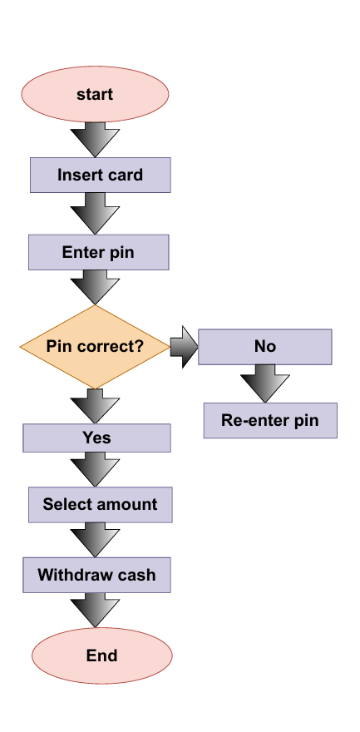
CONCLUSION:
The Power BI dashboard successfully visualizes ATM transaction performance. KPIs and charts provide clear insights into operational efficiency and system reliability. This analysis helps stakeholders monitor performance and make informed decisions.

